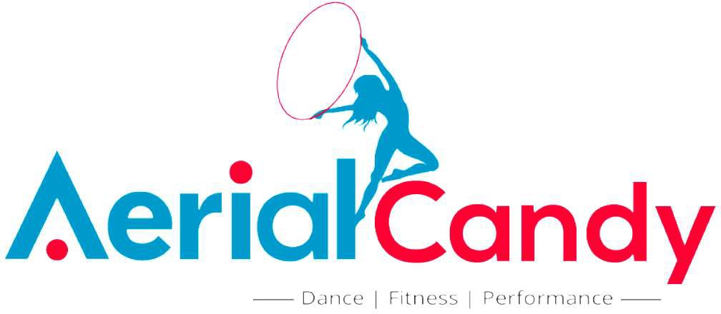

Personal Information
Name: Date of Birth: Address: Phone #: Email: Emergency Contact Name:
Emergency Contact Phone

ADDENDUM TO PARTIPANT’S HEALTH WARRANTY AND RELEASE OF LIABILITY REGARDING COVID-19 AWARENESS
Express assumption of risk: I, the undersigned, am aware that neither Aerial Candy Fit nor Dance Exchange have control over the spread of viral or bacterial diseases, including but not limited to COVID-19. There are risks of the spread of disease involved in any physical training regimen where others are present. These risks include, but are not limited to: failure to assure appropriate social distancing greater than 6’; failure to wear a face covering where others are present; use of shared equipment; failure to follow best practices on hygiene to prevent the spread of disease (including handwashing, avoiding hand-to-face contact); and negligence on the part of myself, my training partner, or other people around me. Illness or disease may result from any number of causes. I should look for signs of any illness or disease and warrant I will not train in person with or through Aerial Candy Fit when experiencing any symptoms consistent with the common cold, flu, fever, COVID-19, or respiratory symptoms. This Waiver and Release of Liability includes, without limitation, assumption of risk if I were to contract a viral or bacterial disease, including COVID-19, in a time period of 2 weeks after Aerial Candy Fit training.

I willingly assume full responsibility for the risks that I am exposing myself to and accept full responsibility for any illness that may result from participation in any activity or class while training with Aerial Candy Fit, either at Dance Exchange 7117 Maple Ave Takoma Park MD, or other locations. I, the undersigned acknowledge that I have no physical impairments or illnesses that I know of that will endanger others or myself.

Initials:

I have read and understood the foregoing assumption of risk, and release of liability and I understand that by signing this addendum regarding COVID-19 awareness it obligates me to indemnify the parties named for any liability for illness, injury, or death of any person and damage to property caused by my negligent or intentional act or omission. I understand that by signing this form I am waiving valuable legal rights.

Signature of Participant: Date:

If the Participant is under the age of 18,

Signature of Parent or Guardian: Date:

(Parent/Guardian) Print Name:

